Industrial Team Project Report

**Team 1**

**Kari McMahon, Mark Goddard, Robert Mason, Ewan Mount and Zhihua Liu**

**AC41004 - University Of Dundee**

**Abstract**

From September 15th 2014 to October 3rd 2014 8 teams worked on developing a diagnostic phone application to aid the field diagnosis of potato disease for the James Hutton Institute’s Malawi potato project as part of the industrial team project module. The report focusses on the software development lifecycle undertaken by team 1 while developing the application. The report outlines various aspects of the lifecycle such as the need for the application, requirement gathering, design, implementation and evaluation of the application as well as focus on the team’s selection of the Agile development process and the necessary project planning/overseeing that goes along with the process. The team use the report to reflect on various aspects of the project, the success and challenges as well as lessons learnt from the project.

**Introduction**

The aim of the project is to develop a diagnostic phone application to aid the field diagnosis of potato disease for the James Hutton Institute’s Malawi potato project. The length of the project was 3 weeks and was undertaken by a team of 5 (Kari McMahon, Mark Goddard, Robert Mason, Ewan Mount and Zhihua Liu).

**Background**

Professor Lesley Torrance from the James Hutton Institute, Invergowrie approached the School of Computing at the University Of Dundee about the possibility of building a diagnostic phone application to aid the field diagnosis of potato disease. This project was given to the fourth year students as their brief for the industrial team project module.

The brief was to build a diagnostic phone application to aid the field diagnosis of potato disease. The team at the James Hutton Institute feel there is a need for this application as potatoes are the world’s 4th most important food crop and in many 3rd world countries are an important cash crop. The James Hutton institute have a particular focus on Malawi a country where 40% of the households cultivate and is the 7th biggest consumer of potatoes in the world but suffers greatly from pests, diseases, potato agronomy and lack of storage. The institute feels farmers could benefit greatly from a low cost infield diagnostic tool which would help identify a variation of problems in their potato fields at the early stages before it starts to spread and could cost farmers money and their crops.

Professor Torrance and her team at the institute are working on a project called the Malawi potato project. The team work on a variation of things such as training in field /evaluation and diagnostics in both Scotland and Malawi, renovated screen house and seed store and the introduction of improved potato cvs in Malawi. The phone application being built will be integrated into this project.

**Specification**

The requirements for the project were gathered in a number of ways. The main method for the requirement gathering was the initial client meeting on day 1 of the project. The additional methods for requirement gathering was the scout trip to the James Hutton institute and email communications with the client.

Initial client requirements

1. As a stakeholder I want an image recognition system to identify potato diseases to aid the diagnosis of potato disease.
2. As a stakeholder I want a searchable glossary of symptoms which link to a further information page about the symptoms.
3. As a stakeholder I want to two field tests videos to help farmers understand how to do these tests.
4. As a stakeholder I want to be able to zoom into images to aid diagnosis
5. As a stakeholder I would like to be able to share images taken from the application to aid diagnosis.

Non functional requirements:

1. As a stakeholder the application should work offline as it will be used out in the field where internet connection will not be available
2. As a stakeholder the application should be scalable as not all pests and diseases will be covered.
3. As a stakeholder the application should conserve battery power.

Technology:

1. Android and iphone ( Not necessary to do both ).

The team generated these requirements from notes from the initial client presentation given to the class. With these requirements the team agreed that they did not think developing image recognition was possible within the time frame. From this we came up with an alternate solution which would be an NHS 24 like expert system where the user would answer certain questions about symptoms and it would give the user the disease relating to these symptoms. The team planned on asking the client if this requirement would be suitable at the scout trip to the James Hutton Institute.

The trip to the James Hutton Institute constituted of a team member from each of the 8 teams. The selected team member for our trip was Kari McMahon. At the meeting the scouts were given an hour long presentation on what Professor Torrance’s team works on at the James Hutton Institute, were shown how to do the FTA and LFD test and could participate in this if they wanted too and the opportunity to ask professor Torrance any questions about the application.

Kari asked professor Torrance voiced her concerns about the ability to develop image recognition where there appeared to be a misunderstanding. When Torrance spoke about image recognition she meant the user looked at the images for the symptom and compared it to the plant on the field. This description already fitted the teams current second requirement. Kari also asked professor Torrance about the expert system which she liked the idea of and Kari also gained a new requirement from professor Torrance which was the user should be able to update the application. Images from the trip can be seen in the appendix.

After the meeting the team wrote up a new a requirements (user stories) document. Then emailed these to professor Torrance to check these were correct. The email can be seen in the appendix. The final decided requirements are below[1]:

Requirements listed in priority:

1. As a stakeholder I want a searchable glossary for leaf, nutrient pests and tubers symptoms which when a sympton is selected leads to a further information page for each symptom that contains six images, basic facts, diagnostics and control information
2. As a stakeholder I want to two field tests videos to help farmers understand how to do these tests.
3. As a stakeholder  I want a decision support tool that will allow me to compare symptoms of plants growing in the field that allow me to make decision about what may be causing my problem and then guide to other pages with info on what to do about it
4. As a stakeholder I want a searchable glossary of symptoms which link to a further information page about the symptoms.
5. As a stakeholder I want to be able to zoom into images to aid diagnosis
6. As a stakeholder I would like to be able to share images taken from the application to aid diagnosis.

Non functional requirements:

1. As a stakeholder the application should work offline as it will be used out in the field where internet connection will not be available
2. As a stakeholder the application should be scalable as not all pests and diseases will be covered.
3. As a stakeholder the application should conserve battery power.

Technology:

1. Android and iphone ( Not necessary to do both ).

The requirements are managed on Trello and can be found here:

<https://trello.com/b/kE5Tl8AA/industrial-team-project>

The requirements are written as user stories as the team are using the Agile approach to software development. This is because the project has a very short time constraint to produce a working solution to meet client’s expectations, test and evaluate the application as well as the necessary documentation to go with it. The agile approach allows the team to take the highest priority requirements they believe they can get done in a time frame of usually a week. This means the client is getting the aspects of the application they really want and the developers are being realistic with the client and not over estimating and hence disappointing the client.

The team told professor Torrance we would be taking the Agile approach and we planned on getting the top two requirements done and if we had time we would try to achieve the rest. Professor Torrance agreed to this approach which can be seen in the email in the appendix.

Due to the short time period of the project and not always being able to have access to the client as they are in Invergowrie. The team could not take a full Agile approach and had to schedule Agile meetings around pre-set times in the timetable. This meant the approach we took in terms of the sprint was not fully Agile and sometimes would feel closer to an iterative approach.

Our work schedule plan for the project was:

* Planning stage – Mon 15th Sept to Wed 17th of Sept 2014
* Sprint 1 – Wed 17th Sept to Wed 24th Sept 2014
* Client Meeting - Wed 24th Sept at 4pm where we review our application with client.
* Sprint 2 - Thurs 25th Sept to Thurs 2nd Oct 2014.
* Hopefully arranging final user testing/evaluation on the Thursday 25th Sept
* Final presentation on the Friday 26th Sept

Although in Agile the team do not usually have a team leader but in the case of this module a team leader must be elected. The team leader for the group was Kari McMahon.

* **Official delivarables + time scales for the project finalise this ?**

**Design**

Once the team had the specifications for the project several design decisions had to be made.

**Device selection**

The first design decision tackled was whether to develop the application for Android, IPhone or both. The client had made clear to the teams that she would like the application to be on both devices but teams did not necessarily have to do both.

To develop for IPhone developers must have access to a mac which not all members in the team have hence this would mean if team members wanted to do work from home this would not be possible which was a disadvantage. The language used to develop iphone applications is objective C which no one in the team has any experience with and is said to be quite a steep learning curve. With around 2 and a half weeks to develop a working prototype to the client we felt it would be best to develop for a device where the team already had some development experience and the time could be focussed on building the project.

The team all had experience with development on Android and all already had the development kits set up on their laptops. This made Android an appealing choice because we could spend more time developing rather than trying to organise setting up the development tools and learning the quirks of a new language. The team also did research into phone usage in Malawi and found that Airtel Malawi is a telecommunications company that is the market leader in Malawi with a market share of 75% (Airtel Malawi, n.d.).

Airtel Malawi’s Android phone prices:

|  |
| --- |
| HUAWEI IDEOS , £46 |
| HUAWEI Ascend Y100, £67.27(Provide by Airtel Malawi) |
| Samsung Galaxy S7562, £159.5 |

Airtel Malawi’s iphone prices:

|  |
| --- |
| Apple iPhone4, £245.5 |
| Apple iPhone4s, £307  Apple iPhone5, £390 |

Prices are from Cellular Abroad (Cellular Abroad, n.d.) and Airtel Malawi (Airtel Malawi, n.d.).

From these values we can see that Android devices are a lot cheaper than iPhone’s so if a farmer or the institute was to purchase a phone to be used primarily for this application. An Android device would be more cost effective for this usage hence the team felt it would be better to develop for Android for the project and extend it the iPhone in the future.

There was one other option that enabled us to develop for both devices which was a development tool like PhoneGap or LiveCode which allow you to develop applications using HTML, CSS and javascript and then export this to both devices. This seemed a good idea and appealed to the team but unfortunately the team had no experience in developing with these tools and again we were concerned how quickly we would be able to pick up an understanding of developing in a system like PhoneGap or LiveCode and create something substantial within such a short time period for the project.

After analysing all the points discussed above the team decided that developing purely for Android had the most benefits for this type of project.

**Development Tools**

At the design stage the team had to decide on the development tools we would use to develop the project on. Most of the team already had the Android development kit on their laptops and used either eclipse or intellij as there IDE so the team kept this way and decided the two IDE’s we would use were eclipse or intellji.

In terms of versioning control we decided to use Github as the team apart from Liu all had some experience with git and already had in installed so we felt it would be best to stick with a versioning control system that the team had installed and were familiar with. Kari also has a private account on Github which meant she could set up the group git to be private which also aided the decision to use this tool. The Github can be found here https://github.com/karivmcmahon/IndustrialTeamProj

For testing the application the team used the emulator that comes with Android while developing aspects of the project and Robert and Ewan both have an Android phones so the team will used these for usability testing, checking features look the same on the phone as well as device and using the phone to demonstrate to the client and to the manager at managerial meetings.

**Database Design**

After the teams decision of developing on Android we needed to decide on the type of database the device would use to store the potato disease information. The client made clear she would like the application to work offline but also to be scalable.

For the application to work offline we decided to use the in phone SQLite database to store the information for the glossary. We planned on developing the application with the in phone database so the application could work offline as the requirement to have a glossary of symptoms and videos of the test were the highest requirements and the ones we promised to achieve.

Since there was also a requirement to be able to make the application scalable and updatable. The team designed a solution for this which would be implemented if the team had time in the project or could be implemented in the future. The solution was a website where the user could update the information to a server version of the SQLite database and then when the phone had an internet connection it would sync the in phone database with the server database and update the application. Hence also making the phone scalable and work offline.

SQLite database was chosen for the reason it is the database Android uses to store information within an application enabling the application to work offline. A SQLite database uses an application file format so it more easily accessible and cross platform which is useful if the feature to implement syncing between the server and in phone databases. It also has a very small code footprint and makes efficient use of memory, disk space and disk bandwith which is useful to be used in a phone application as they cannot cope with databases which take up a large amounts of memory. SQLite also claims to support terabyte-sized databases and gigabyte-sized strings and blobs which makes this database choice useful for scalability (SQLite , n.d.). The only issue with the choice of using SQLite as out database is only two members of the team have experience with this database so we were aware there may be a learning curve for some members of the team.

Database table design

Website sketch

**Sketches**

Below are the finalised design sketches of the application the team came up with from the requirements. The sketches were used as an aid to the team when developing the application. Larger versions of the sketches can be found in the appendix.

Glossary Page Sketch

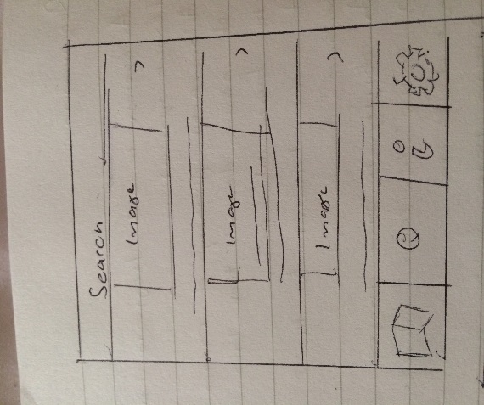

Further Information Page Sketch

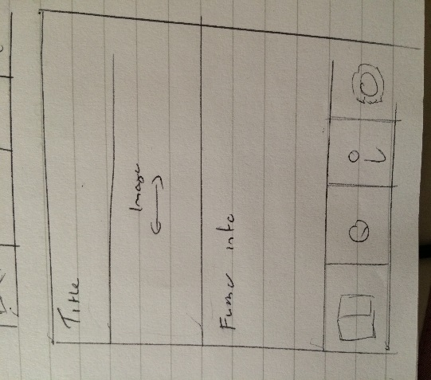

Expert System Page Sketch

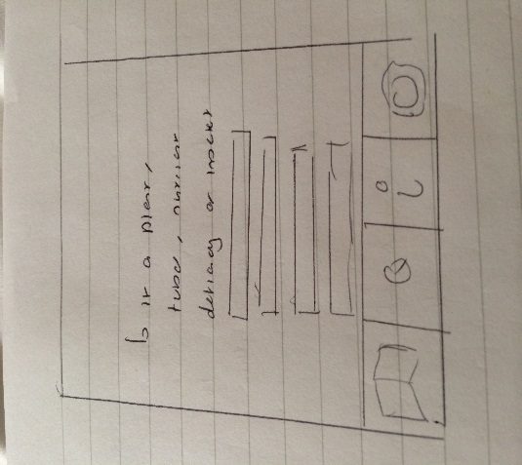

Video Tutorials Page Sketch

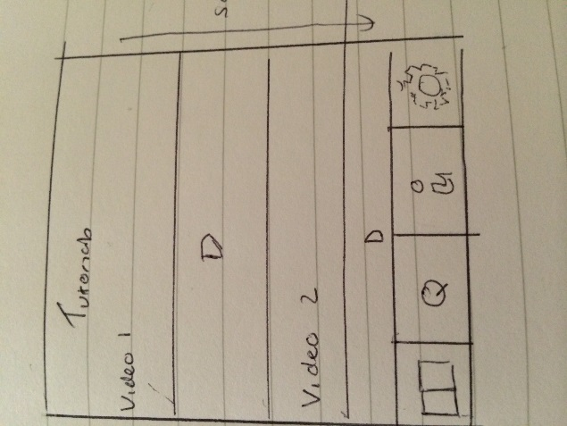

**Project Planning**

At the design stage in the project the team discussed several ways to manage the project. The first was to minute the daily meetings. The minutes would summarise what happened at the meeting. The task achieved that day or from the previous day and tasks to do before the next meeting.

The plan for the daily meetings were 9am – 5pm where we would work on the project in the labs. The reason for these meetings was to stick to the Agile approach of working 9am – 5pm in the same environment as each other as it should make it easier to communicate changes or updates in the project, show progress and make sure the project is on track. The team also agreed at the start of every meeting the team would have a quick 10 minute SCRUM where each member would say what they did the day before, what they were going to do and any obstacles. This is an Agile technique which helps all the members in the team know where each other is at in the project and try to quickly solve any obstacles that may be causing issues for team members. The minutes would document information from the scrum and any other details from the rest of the meeting throughout the day. The majority of the minutes throughout the project were documented by Kari and can be found in the appendix.

Often with team projects there tends to be more risk involved than with an individual project where you are just managing yourself. During the project planning and design stage of this project the team developed a risk assessment which all members of the team could access on the Github which stated the biggest risks to the project and 2 preventions to deal with the risks. This was so that if any of the risks occurred the members of the team would know how to manage the risk before it had detrimental effects on the project.

As stated above the team decided on using Trello to manage the project requirements as it is flexible to move requirements around and edit them, it’s easy to colour code the requirements in terms of what’s to be done, in progress and finished and it is online so all team members can access Trello wherever they are. To manage the requirements selected for a sprint the team choose to use a sprint backlog which outlines the dates of the sprints, the requirements being done and tasks related to this requirement, how long each task will take and who’s been doing them. The sprint backlog enables the team to see if the project is on track, if team members are over allocated and under allocated on tasks as well as a good way to list additional tasks that don’t relate to the project but are also deliverables like the user guide, final report etc. The sprint backlog was the main tool to aid project planning throughout the implementation stages. The team decided on the use of the backlog as we all had seen the benefits of using one when taking the Agile module in third year. The sprint backlog can be found in the appendix.

The session with the careers team on personality profiling was also useful in terms of understanding where our skills lie within the team. At the end of the session Kari and Ewan were given a cool blue profile and Robert and Liu were given a fiery red profile. Unfortunately Mark did not make it to the personality profiling session so the team did not know what colour he was. From the session the team were aware they were missing a yellow and green personality and would have to be mindful of this throughout the project and make an effort to bring out their green and yellow personality skills which may sometimes be hidden. The session made us aware of the benefits and challenges of having each colour in our team enabling us to be mindful of how to deal with each personality type within our team which would aid the team in project planning and managing. Below is an image of our team from this session.

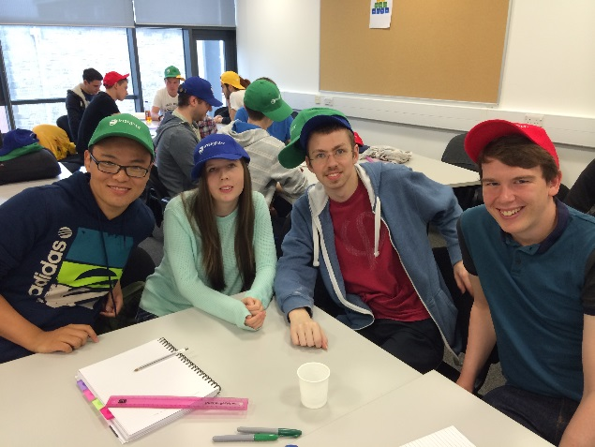

As stated in the specifications the team developed an Agile like work schedule around the pre-set meetings with the client. We planned on the schedule below during the planning and design stage:

* Planning stage – Mon 15th Sept to Wed 17th of Sept 2014
* Sprint 1 – Wed 17th Sept to Wed 24th Sept 2014
* Client Meeting - Wed 24th Sept at 4pm where we review our application with client.
* Sprint 2 - Thurs 25th Sept to Thurs 2nd Oct 2014.
* Hopefully arranging final user testing/evaluation on the Thursday 25th Sept
* Final presentation on the Friday 26th Sept

The schedule above was designed/planned to enable us to build some functionality, gain feedback from the client then from this feedback build/change functionality over the space of the week where we are able to contact the client about changes over email. Then with the new functionalities to gain some finalised evaluation of the application from users in time for the final presentation of the product to the client at the end of the project.

**Ethics**

At the design stage of the project the team wrote an ethics form which outlined the teams plan to do user testing to gain understanding of the usability of our application and if the users finds the application clear and easy to understand. As well as doing user testing the team also planned on doing an evaluation of our application against a current application on the market for certain tasks to see if our application is better than the applications currently on the market for aiding diagnosis of potatoes. The study will involve filling out a quick demographic form, the user testing or evaluation task then filling out a SUS form on the usability of the applications. This will help us understand the usability of the application and evaluating if our application has been successful. In the appendix you can find the ethics form along with the demographic sheet, consent form, SUS usability form and the basic task sheet.

**Confidentiality, professionalism, image rights etc**

**James Hutton Institute**

**Implementation**

* **Sprints**
* **Scrum**
* **Retrospective**
* **Backlog**
* **Successes**
* **Challenges**
* **Techniques – pp, refactoring, unit testing**
* **Research**
* **Android study**
* **Mention of user guide (video )**

**Evaluation**

* **Client evaluation**
* **Group testing**
* **User evaluation**
* **Evaluative study**
* **Changes from sketches**
* **Rapid prototypes**

**Final product**

* **Final product**
* **Description**
* **Look**

**Appraisal**

* **Project management challenges**
* **Client expectations**
* **Successes**
* **Issues**
* **Technique issues**
* **Lessons learnt**
* **How to improve in the future**
* **Personal development training**
* **Team experience + technological improvement**
* **James Hutton Institute experience**

**Summary & Conclusion**

**Future**

**References**

**Appendix**

* **Trello link**
* **Backlog**
* **Risk assessment**
* **Sketches – Database + design**
* **Requirement sketches**
* **Minutes**
* **Emails and meetings with client**
* **Pictures from James Hutton Institute**
* **Picture from personal development**
* **Log book**
* **User guide - Video**

**Binded + on disk**

1. One of the requirements changed in priority after the email communication as we felt the videos were higher priority over the expert system based on the email reply and trip to the institute